Attribution Theories extra reading
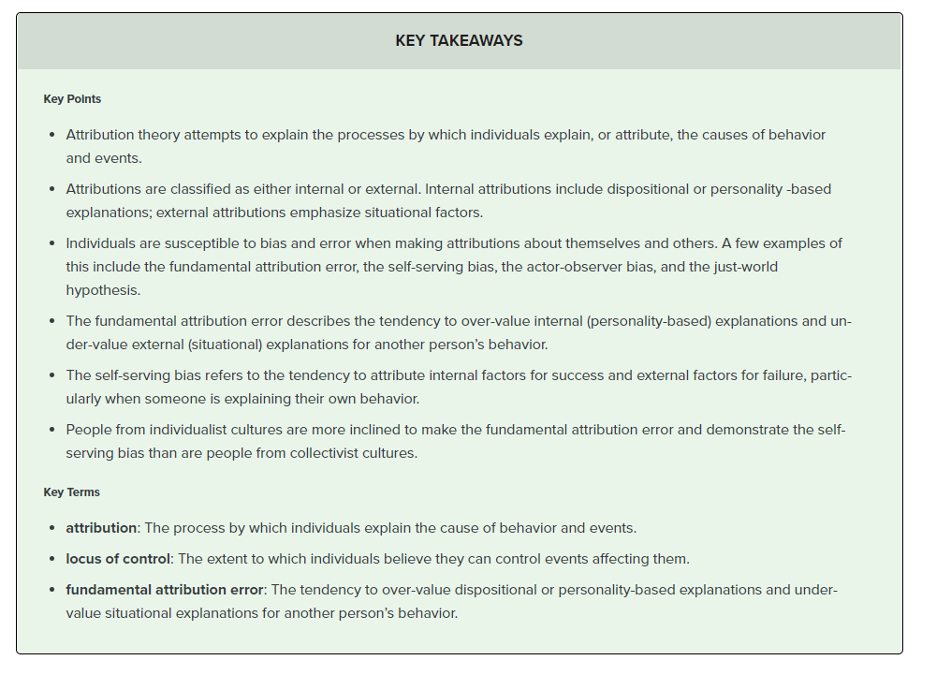
One of the central concerns of social psychology is understanding the ways in which people explain, or “attribute,” events and behavior. “Attribution theory” is an umbrella term for various models that attempt to understand this process.
Explanatory and Interpersonal Attribution (Seligman)
In our attempts to make sense of the world around us, we tend to look for reasons and causes behind events and situations. To do this, we make either explanatory or interpersonal attributions.
An explanatory attribution is an attempt to understand the world and seek reasons for a particular event. People with an optimistic explanatory style attribute positive events to global, stable, internal causes and negative events to specific, unstable, external causes. The inverse is true for those with a pessimistic explanatory style: they attribute negative events to global, stable, internal causes and positive events to specific, unstable, external causes.
An interpersonal attribution is an attempt to explain the reasons for an event based on an interaction between two or more individuals. When explaining negative situations, for instance, individuals tend to explain the event by attributing fault to the other person, such as by concluding that they must have a certain negative personality trait or must have been in a bad mood.
Internal and External Attribution (Heider)
Attributions can also be classified as either internal or external. Internal attributions emphasize dispositional or personality-based explanations, while external attributions emphasize situational factors. For example, when a person aces a test, an internal attribution might be the conclusion that she must be very smart. An external attribution for the same outcome might be that she must have received extra help before the test or that the test was too easy.
Attribution Models
There are multiple models that attempt to explain the kinds of attributions we use. Two of the most well-known models are the covariation model and the three-dimensional model.
Covariation Model of Attribution (Kelley)
The covariation principle states that people attribute behavior to the factors that covary with that behavior. This means that the “causes” they identify are present when the behavior occurs and absent when it does not. This theory assumes that people make causal attributions in a rational, logical fashion and will assign the cause of an action to the factor that seems most closely associated with it.
According to this theory, there are three types of information an individual will consider when making an attribution:
- consensus, or how other people in the same situation behave;
- distinctive information, or how the individual responds to a different stimulus; and
- consistency, or how frequently the individual’s behavior can be observed with a similar stimulus but in a different situation.
Based on these three pieces of information, observers will make a decision as to whether the individual’s behavior is either internal or external. For example, if your friend raves about a film, you may consider his response compared to other people’s response (consensus), whether your friend raves about other films (distinctive), and whether he always raves about this film (consistency). If other people love the film, your friend does not tend to rave about films, and he consistently praises this film, you might make the external attribution that the film must in fact be good. If no one else loves the film, your friend always raves about films, and he does not consistently praise this particular film, you might make the internal attribution that there must be something specific to your friend that made him enjoy and rave about the film.
Three-Dimensional Model of Attribution (Weiner)
This model suggests that a person’s attributions and perceptions about their own success and failure determines the amount of effort the person will put forth in similar situations in the future. When attributions lead to positive feelings and high expectations of future success, the person will likely be more willing to approach similar tasks in the future. Similarly, attributions that produce negative feelings and low expectations for future success will make the individual less willing to put forth effort toward similar tasks in the future.
There are three components of attributions under this model.
- Locus of control . Someone’s locus of control can be either internal or external. An individual with an internal locus of control sees people as active participants in the world, capable of influencing what happens to them. Someone with an external locus of control sees the world as happening to people, outside of their control.
- Stability. This refers to whether someone’s attribution is stable (lasting) or unstable (changeable) over time.
- Controllability. This is the extent to which a cause is able or unable to be controlled. For example, level of effort put forth may be controllable, while raw talent or ability is not.

Attribution Biases and Errors
People are susceptible to bias and error when making attributions about themselves and others. A few common such biases include the fundamental attribution error, the self-serving bias, the actor-observer bias, and the just-world hypothesis.
Fundamental Attribution Error
According to social psychologists, people tend to overemphasize internal factors as explanations for the behavior of other people and do the opposite when explaining our own behavior. That is to say, we tend to assume that the behavior of another person is due to a trait of that person, underestimating the role of context. For example, when a student fails to turn in his or her homework, a teacher may assume the student is lazy rather than attributing the behavior to external contextual factors such as having a particularly busy schedule that week. This perspective is called the fundamental attribution error and may result from our attempt to simplify the processing of complex information.
The fundamental attribution error is so powerful that people often overlook even obvious situational influences on behavior. This can contribute to prejudice and stereotyping and lead to conflict.

Fundamental attribution error: The fundamental attribution error explains why when someone cuts us off we assume he or she is bad-natured, but when we cut someone off we believe it is because the situation required it.
Self-Serving Bias
Self-serving bias is the tendency of individuals to make internal attributions when their actions have a positive outcome but external attributions when their actions have a negative outcome. This bias lets us continue to see ourselves in a favorable light and protects our self-esteem; we take credit for our successes and pin our failures on other factors. For example, if an individual gets promoted, he may attribute it to his performance; if he fails to get the promotion, he may attribute it to his supervisor possibly having a grudge against him.
Actor-Observer Bias
The actor-observer bias explains the phenomenon of attributing other people’s behavior to internal factors while attributing our own behavior to external or situational forces, also known as the fundamental attribution error (Jones & Nisbett, 1971; Nisbett, Caputo, Legant, & Marecek, 1973; Choi & Nisbett, 1998). When we are actors of behavior, we have more information about the situation to help us form an explanation, but when we are merely observers, we have less information; therefore, we tend to default to the assumption that others’ actions are based on internal factors rather than the situation.
Just-World Hypothesis
One consequence of Westerners’ tendency to provide internal explanations for others’ behavior is victim-blaming (Jost & Major, 2001). When bad things happen to people, others tend to assume that those people somehow are responsible for their own fate. A common view in the United States is the just-world hypothesis, which is the belief that people get the outcomes they deserve (Lerner & Miller, 1978). In order to maintain the belief that the world is a fair place, people tend to think that good people experience positive outcomes and bad people experience negative outcomes (Jost, Banaji, & Nosek, 2004; Jost & Major, 2001). This worldview allows us to feel that the world is predictable and that we have some control over our life outcomes (Jost et al., 2004; Jost & Major, 2001).

Trayvon Martin: Trayvon Martin, a 17-year-old African-American youth, was fatally shot by George Zimmerman, a white volunteer neighborhood watchman, in 2012. His death sparked a heated debate around the country about the effects of racism in the United States. Social psychologists theorize about how different cognitive biases influence different people’s perspectives on Martin’s death.
Cultural Factors
Research shows that culture affects how people make attributions. Individualist cultures value personal goals and independence. Collectivist cultures see individuals as members of a group and tend to value conformity, mutual support, and interdependence. People from individualist cultures are more inclined to make the fundamental attribution error and demonstrate self-serving bias than people from collectivist cultures. This is thought to be because individualists tend to attribute behavior to internal factors (the individual), while collectivists tend to attribute behavior to external factors (the group and world).

